**Modules**

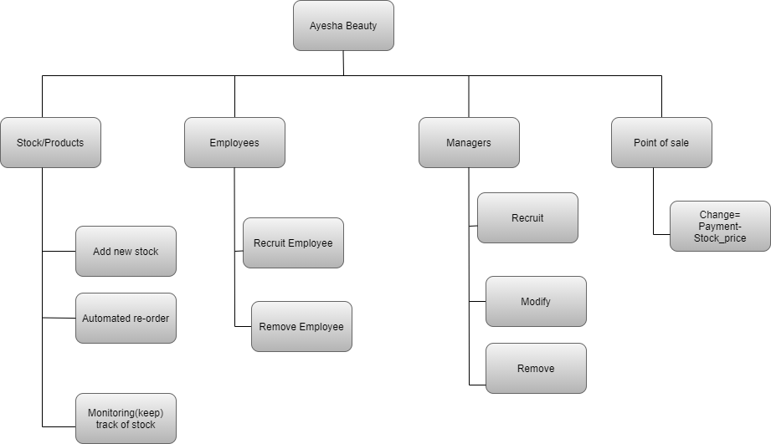

Functions

Stock

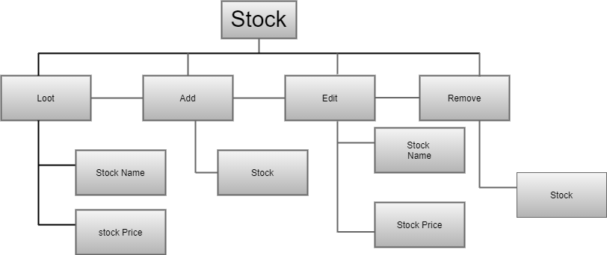

Employee

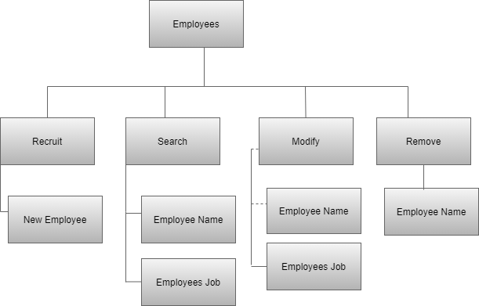

Manager

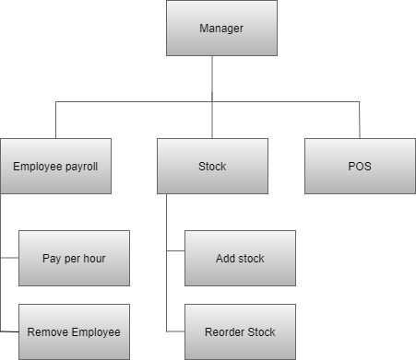

Point of sale

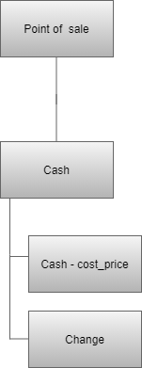

PSEUDO CODE

Pseudo code 1

**1. Start**

**2. Prompt product name**

**3. Prompt min product quantity**

**4. Read product quantity**

**5. Read product price**

**6. Display "enter product name"**

**7. Display product quantity and product name**

**8. If product quantity<min product quantity**

Then

**9 Display “stock of (product name) is insufficient, please re-order"**

Else

**10 Display "there is sufficient stock"**

**Endif**

**End**

Pseudo code 2

**1. Start**

**2. Prompt product name**

**3. Prompt product amount**

**4. Read total price**

**5. Read product amount**

**6. Read tax rate**

**7. Read product price**

**8. Display "enter product name and product amount"**

**9. If product amount=> product quantity**

Then

**10. Compute total price = (product price*product amount)* tax rate**

**11. Display total price**

Else

**12. Display "(product name) is out of stock**

**Endif**

**End**

Pseudo code 3

**1.Start**

**2.Prompt employee surname**

**3.Prompt job grade**

**4.Prompt high salary**

**5.Prompt low salary**

**6.Read employee name**

**7.Read work time**

**8.Read salary**

**9.Read employment type**

**10.Display "enter employee surname"**

**11.If job grade == good**

**Then**

**12.Salary = high salary*work time**

**Else**

**13.If job grade==bad**

**Then**

**14.Salary==low salary*work time**

**15.Display salary**

**Endif**

**Endif**

**16.If employment type== permanently**

**Then**

**17.Display "this employee is permanently employed"**

**Else**

**18.If employment type== contract**

**Then**

**19.Display "this employee is on contract"**

**Endif**

**Endif**

**End**